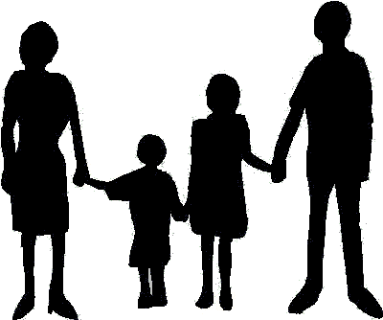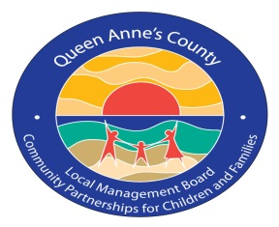Queen Anne’s County Young People Who Care Youth Grant Award
Established
1978

Council for Children & Youth
Community Partnerships for Children & Families
Permission Form
DATE: .

YOUTH NAME: Print Signature .

PARENT/GUARDIAN NAME: Print Signature .
I, as parent/legal guardian, give permission for , to create and/or implement a community service project to benefit Queen Anne’s County citizens. I also give permission for , to participate in media outreach on his/her project as well as in publication and marketing strategies by Council for Children and Youth and Community Partnerships for Children and Families.
Please circle your approval:
Print Media YES/NO Website YES/NO
QACTV YES/NO Facebook YES/NO
Grants YES/NO Fundraising Letters YES/NO
Photo Permission: YES/NO
The undersigned on himself/herself and the minor child named herein do hereby release, waive and quit-claim any and all claims, demands or causes of action arising from or incident to the participation of the named participant in the activities above described with the intent to formally release and exonerate the Queen Anne’s County Council for Children and Youth and the Community Partnerships for Children and Families and its agents, employees, volunteers and officers from any and all such claims.

